Notice of Marin County Deputy Zoning Administrator Hearing
Bolinas Community Public Utility District Coastal Development Permit and Conditional Use Permit

Project Address: Properties with no addresses in Bolinas APN(s): 193-030-38 and 193-020-45 Project ID:P4376
Project Planner: Megan Alton (415) 473-6235 megan.alton@marincounty.gov
Project Summary: The applicant, Bolinas Community Public Utility District, is requesting Coastal Development Permit approval to connect an existing non-potable well to the Bolinas Community Public Utility District drinking water distribution system as an emergency water supply source for use during drought years.
Date of DZA Hearing: Thursday, June 27, 2024
Hearing Location: 3501 Civic Center Drive, Rooms 328/330, Administration Building, San Rafael, California
Hearing Time: DZA hearings generally begin at 10:00 AM, but a more precise time will be indicated on the hearing agenda posted on the DZA hearing webpage one week before the hearing.
Staff Report: Available on the project webpage and the DZA hearing webpage on Friday, June 20, 2024.
The decision on this application may be appealed to the Planning Commission. If you challenge the decision on this application in court, you may be limited to raising only those issues you or someone else raised at the public hearing described in this notice, or in written correspondence delivered to the Planning Division during or prior to the public hearing. (Government Code Section 65009(b)(2).)
More information about this application is available online at
http://www.marincounty.org/depts/cd/divisions/planning/projects, where projects are listed for the Bolinas area.
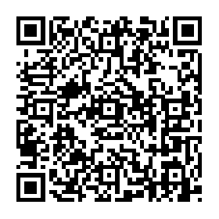
All public meetings and events sponsored or conducted by the County of Marin are held in accessible sites. Requests for accommodations may be made by calling (415) 473-4381 (Voice) 473-3232 (TDD/TTY) or by
e-mail at disabilityaccess@marincounty.org at least four work days in advance of the event. Copies of documents are available in alternative formats, upon request.

«Owner»
«OwnerAddress»
«MailLine2»
«MailCareOfName»
«MailCity», «MailState» «MailZipCode»

