----------------------------------------------------------------------------------------------------------------------------

MARSHALL SYSTEM FIELD TOUR

Discover Wastewater Management Excellence

---------------------------------------------------------------------------------------------------------------------------

Date: September 16, 2023

Time: 9:30 am – 11:30 AM

Location: 19225 CA-1, Marshall, CA 94940

----------------------------------------------------------------------------------------------------------------------------

Agenda:

1. Welcome and Introduction

- Duration: 15 minutes

- Location: The Marshall Store (19225 CA-1, Marshall, CA 94940)

- Overview of the wastewater treatment facility

- Meet key personnel leading the tour

2. Facility Tour

- Duration: 1 hour

- Guided tour of the wastewater treatment facility and leachfield

- Learn about different stages of wastewater treatment

- Discover innovative technologies for effective management

3. Q&A Session

- Duration: 30 minutes

- Engage in interactive discussions

- Get answers to your questions from our experts

4. Conclusion and Networking

- Duration: 15 minutes

- Recap of key takeaways

- Opportunity for informal networking with community and staff

----------------------------------------------------------------------------------------------------------------------------

Hosted by:

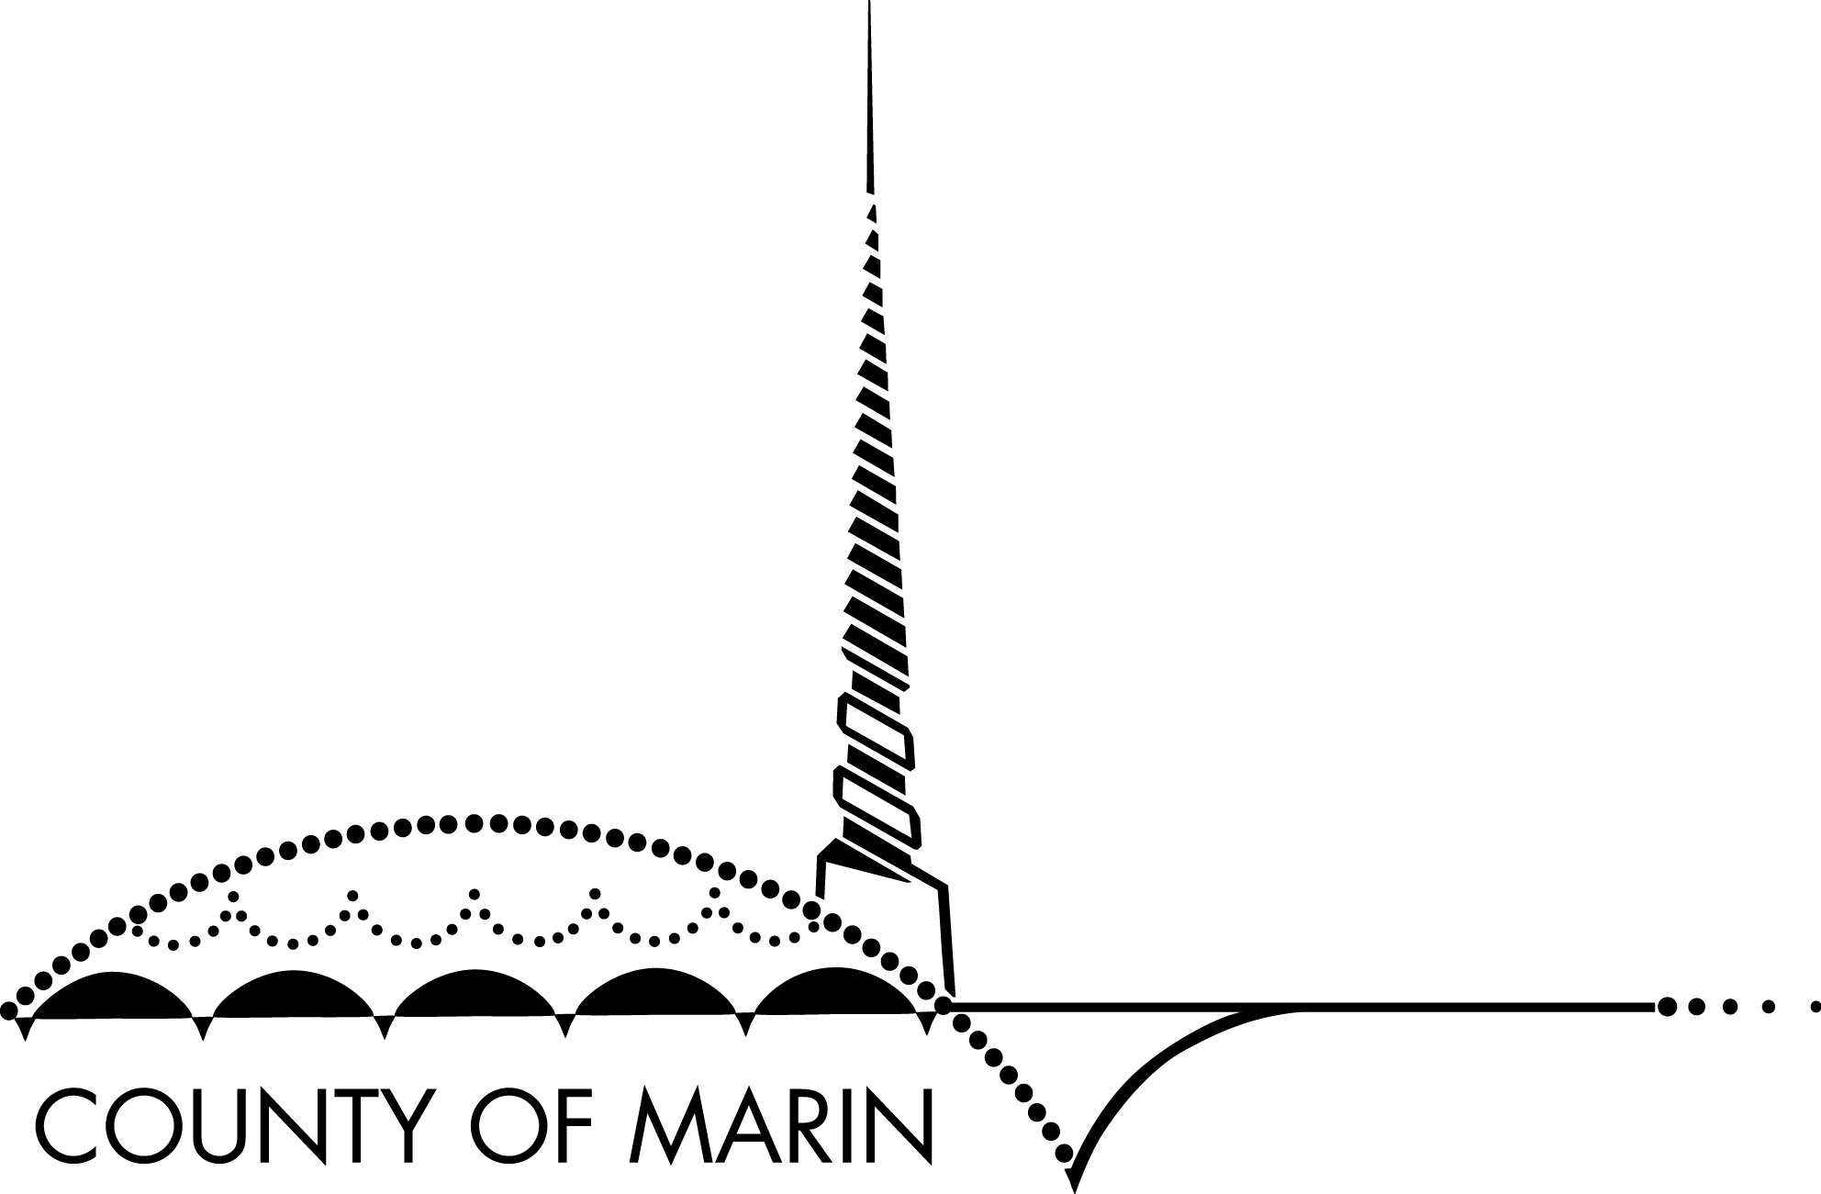MARIN COUNTY ENVIRONMENTAL HEALTH SERVICES

Address: 3501 Civic Center Drive, Suite 236, San Rafael

Contact: 415-473-7146 extn. 711, akundu@marincounty.org

------------------------------------------------------------------------

Join us to explore wastewater management practices,

connect with EXPERTS AND make a positive impact on the environment.

